**A review of HCAHPS Scores at CA Hospitals | Write-up**

* **What are the counties that do not have good HCAHPS Scores?**

We plotted the Max “Overall HCAHPS scores” per county, and we found that there are two counties (Del Norte and Yuba) that had low max “overall HCAHPS scores”. These counties are Del Norte and Yuba.

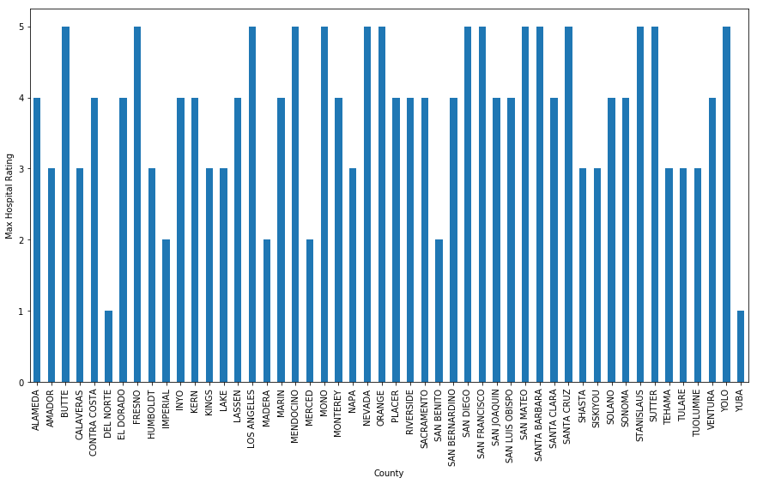

* **Do hospitals in high-income areas in CA get a higher overall HCAHPS score?**

We were expecting to see a correlation between HCAHPS score and median income per county, but we did not find this in our data sets.

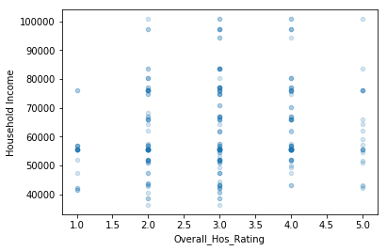

* **Does population have any effect on overall HCAHPS Score?**

We wanted to see if there was any correlation between HCAHPS score and population, but we did not find any correlation in our data sets.

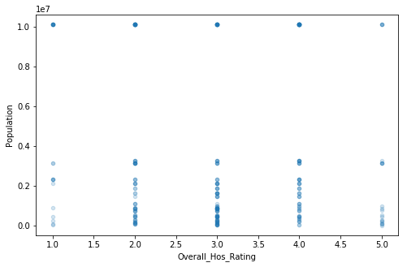

* **Is there any correlation between different HCAHPS rating categories?**

Nurse Communication, Doctor Communication, Pain Management and Care Transition have the highest positive correlation with the overall rating. This implies that these four factors impact the overall rating the most and this impact is in a positive fashion, meaning that, for example, a higher pain management corresponds to a higher overall rating.

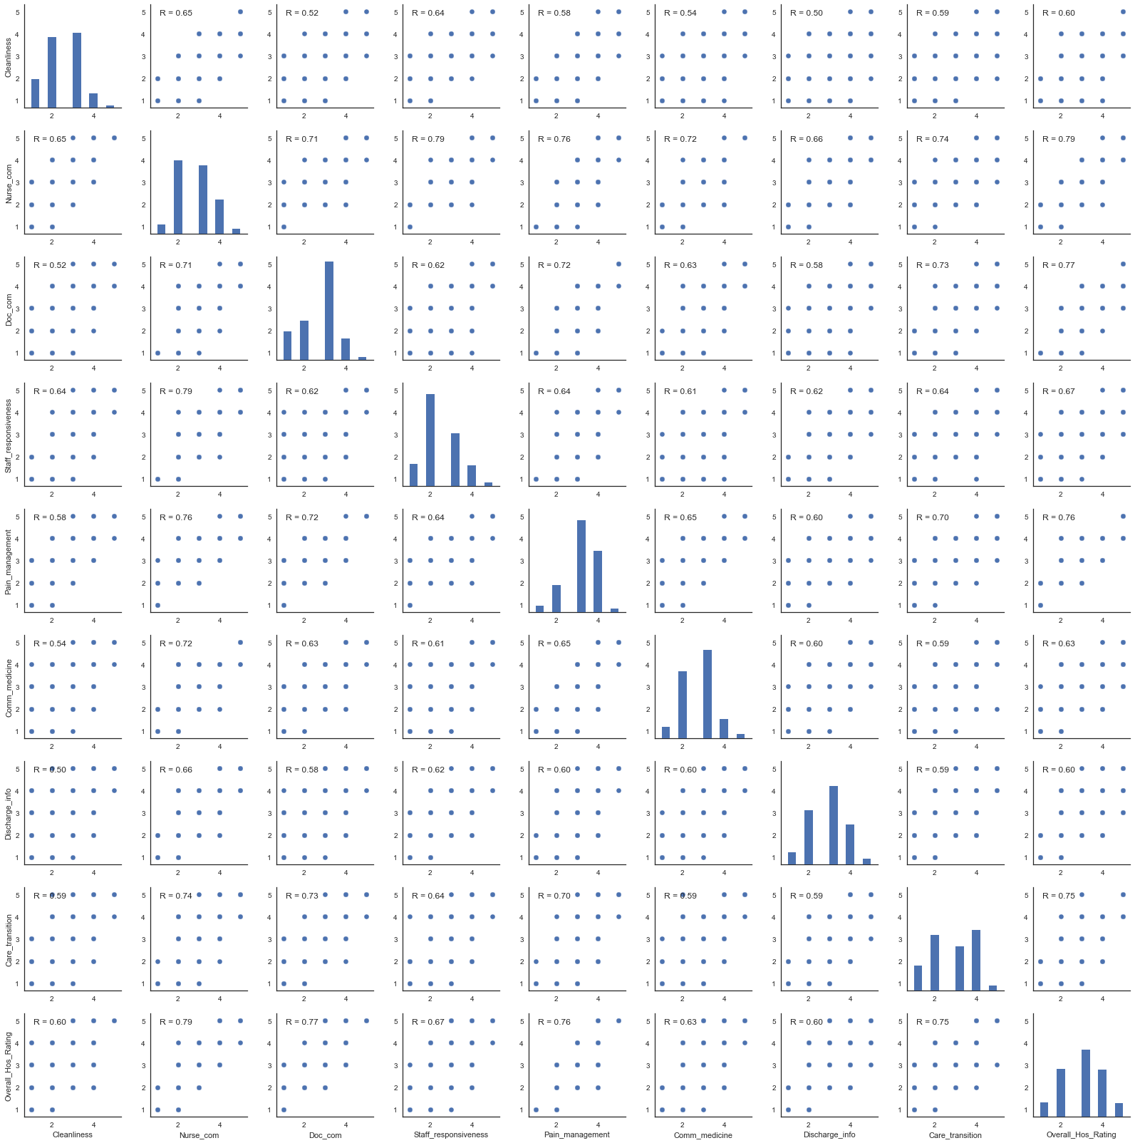

* **Does the type of hospital ownership have any effect on HCAHPS Score?**

Among the different hospital ownerships, government-federal hospitals have the most consistent scores with respect to all the ratings from multiple surveys. More precisely, the scores of government-federal hospitals are rather compactly distributed around the average which means that a consistent service is offered within the government-federal hospitals.

